MIS 2100 Minor Homework

SQL SELECT Queries

70 points

# Objective

In this exercise, students will become familiar with the structure of a simple, retail-oriented relational database and practice writing SQL SELECT statements. In the process, students will learn to identify relationships between tables through the use of primary and foreign keys.

# Start-Up Hints

For this assignment, you will be using a database diagram to practice a few queries. Then, when we go into the major assignment – you will be importing a dataset into Microsoft Access and pulling actual data from the dataset by writing SQL queries. But for this assignment, it contains two parts to get you introduced to the components of a dataset as well as some preliminary queries that you will be using to help prepare you for the Major Homework Assignment for SQL Queries.

Submission: Write your answers/queries to the questions below under the question in a clearly labeled, well-formatted manner. You will submit this assignment in Canvas.

# Background

For this assignment, we’ll be using the database for DustBunny Vacuums, a [fictional] vacuum cleaner manufacturer. The company sells products in-person at events as well as through its website. The company has provided sales results for the period from August 11-20, 2017, included in the tables indicated in the data dictionary and diagram below.

A couple of items of note:

* LineTotal = The total value of one “line” of an order — a record (or line) in the OrderLine table is similar to the line on a receipt; it includes information about what product was purchased (ModelID), the price of that product (ModelPrice), and how many of the product were purchased (Qty). The LineTotal, then, is simply the product of Qty multiplied by the ModelPrice.
* Also, be aware that each SalesOrder shown in the SalesOrder table is comprised of one or more OrderLine records, corresponding to the number of different products that were included as part of that SalesOrder.

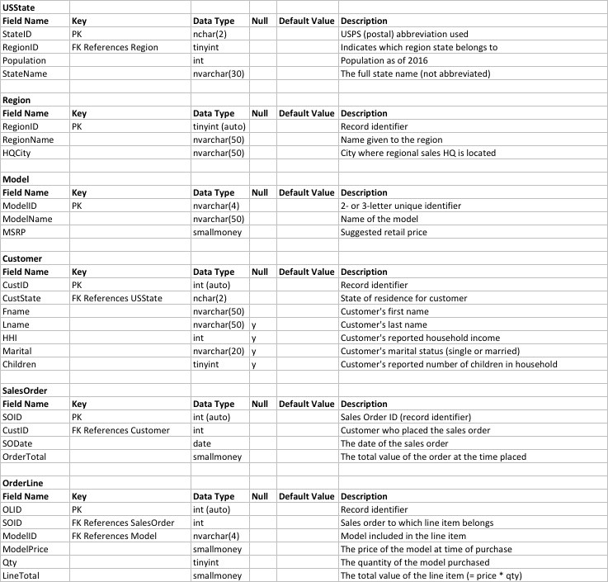

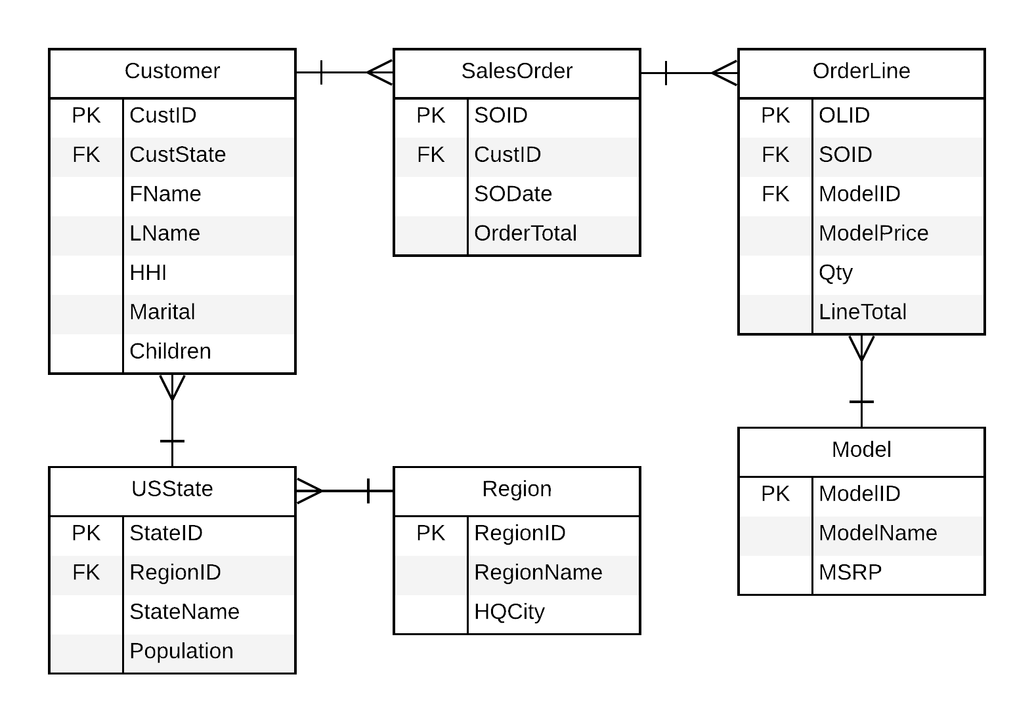

# Assignment

## Part A

1. For each of the tables in the database, identify the name of the Primary Key field (for each, list both the table name as well as the corresponding primary key). (5 points)
2. For each relationship in the database, identify the names of the tables in the relationship as well as the names of the fields that “create” the relationship. (5 points)

## Part B

For problems 3-7, complete queries for each of the output requests. **For each query**, include (a) the problem number (3-7), and (b) the SQL text used in your SELECT statement, (10 points each). Again, refer to the diagram above as you complete this assignment (similar to the PP slides for this module).

1. Output the name of each region as well as the city where the sales headquarters is for that region. Your output should include only these two fields and should be ordered alphabetically by the name of the region.
2. Output the state name and 2016 population for every state with a population greater than 8 million. Order the output from largest state (by population) to smallest.
3. Output the customer name (fname and lname), marital status, state (use the two-letter code), and household income for all customers located in Montana (MT), Nevada (NV), Texas (TX), and Washington (WA) who have a household income of over $140,000 and are single. Order results alphabetically by last name.
4. For all orders placed on August 15, 2017 and valued at $850 or more, show the customer’s name (first and last), the order number, and the order total. Results should be put in order from the largest value to the smallest.

## Part C

1. Finally, come up with two original queries that you think could help lead to important insight for the company (20 points).

The query should not be something “obvious” (e.g., don’t count the number of products the company sells). For your query, report each of the following:

* 1. Describe what the query will output (i.e., what are you trying to show with the query?).
  2. Provide the SQL query itself.
  3. Describe how DustBunny might use this query to gain insight into their business